East Knox 25/26 Fifth Grade Supply List
Backpack (no wheels please) | 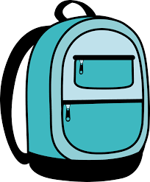 | 1 pair of headphones  or earbuds | 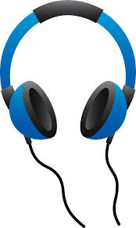
48 Sharpened No.2 Pencils | 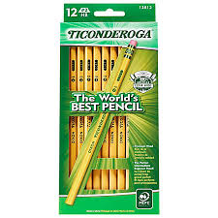 | 2 packs of Pencil Cap Erasers | 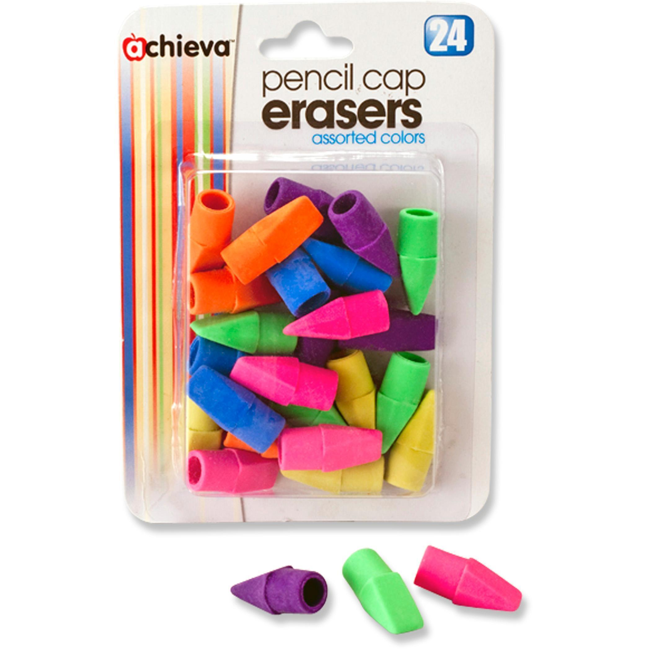
1 3 Ring Binder, 2 inch | 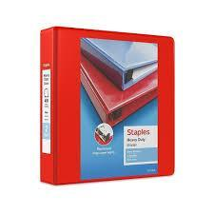 | 2 packs of 5 tab dividers | 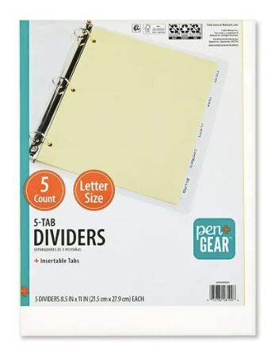
Index cards with lines | 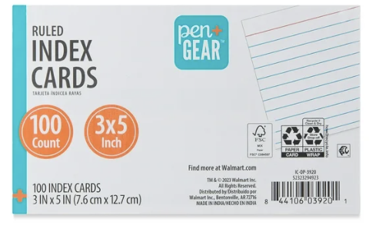 | 3 packs of notebook paper | 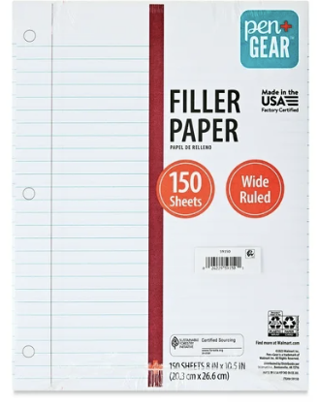
2 packs of 12 count colored pencils | 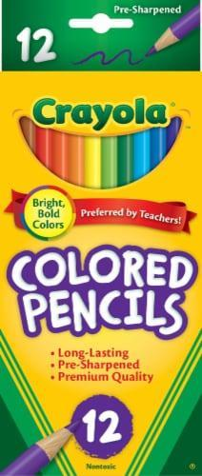 | 2 packs of 4 dry erase markers (black and colorful) | 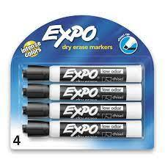
Scissors | 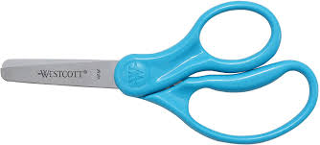 | 1 LARGE Pencil Pouch with zipper & 3 holes to fit in binder | 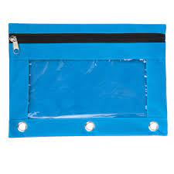
4 Box of Tissues (extra is always appreciated) | 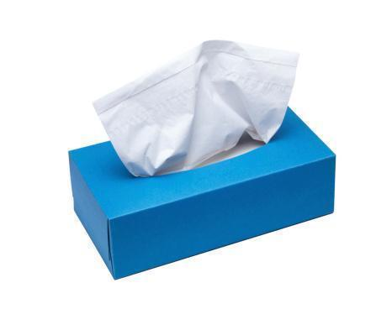 | Multi-color packs of highlighters | 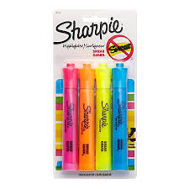
1 box of Crayons | 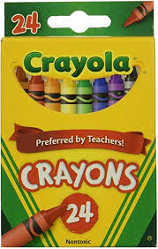 | 1 box of quart/gallon Ziplock bags | 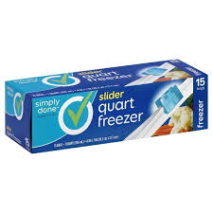
Red, blue, purple vinyl 3 Prong Folders w/ pockets | 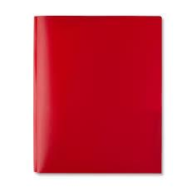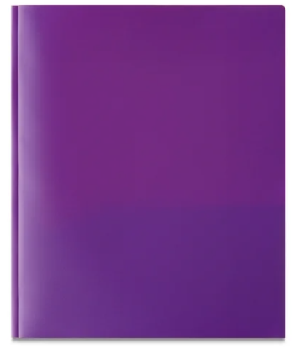 | Lanyard with ID pouch | 